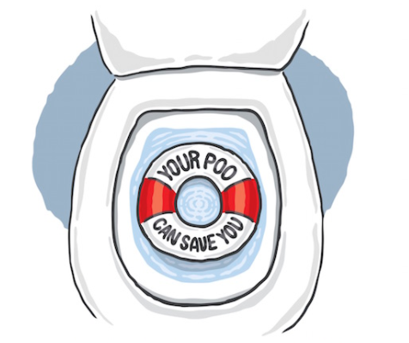

Bowel Cancer is a common cancer in the UK.
Early detection really helps with the chance of cure.
Please come and see your doctor if:
- You notice blood in your poo
- You have a persistent change in bowel habit
- You have unexplained weight loss
- You have extreme tiredness
- You notice a lump or pain in your stomach
Can I reduce my risk of bowel cancer? YES!
- Eat a healthy diet with regular fruit and vegetables
- Try to limit the amount of processed meat in your diet
- Quit smoking
- Take regular exercise
If you would like help and advice with these please let reception know
Are you between 60-74 years?
You should be screened for bowel cancer every two years.
It is simple to do this. You will be given a kit which involves putting a small sample of poo into a plastic tube and posting it back in a prepaid envelope. The test can spot signs of bowel cancer really early.
Ask at reception or call free on 0800 707 6060

